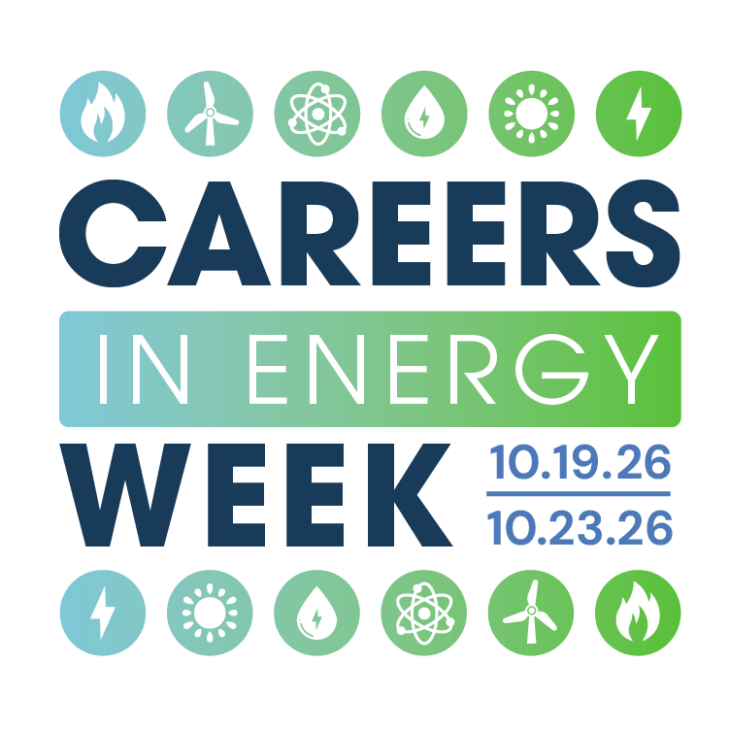

A Proclamation Recognizing October 19-23, 2025, as Careers in Energy Week
Whereas, the United States of America relies upon a robust energy sector to power its homes, businesses, industries, and infrastructure; and
Whereas, access to safe, secure, reliable, and low-cost energy is fundamental to our nation's economic prosperity, national security, and the health and well-being of all Americans; and
Whereas, the energy industry encompasses a wide array of career paths, from traditional fossil fuel production and renewable energy generation to cutting-edge research, engineering, and technology development; and
Whereas, the dedicated and skilled workforce of approximately 8 million men and women across the nation are the backbone of our energy infrastructure, ensuring the continuous and efficient delivery of energy to our communities; and
Whereas, these professionals exhibit unwavering commitment, technical expertise, and a deep sense of responsibility in maintaining and advancing our energy systems; and
Whereas, industry employers will need tens of millions of replacement and new workers over the next decade; and
Whereas, it is essential to raise awareness about the rewarding and vastly growing career opportunities available in the energy sector, particularly among students and young professionals; and
Whereas, highlighting the importance of energy education and training will help to cultivate a pipeline of skilled workers to meet the evolving needs of our nation's energy future; and
Whereas, recognizing the contributions of our energy workforce will foster a greater appreciation for the vital role it plays in powering our lives and fueling our future;
Therefore, I, (_______________, ________________) of _______________
name title town/county
do hereby proclaim that October 19-23, 2025, be designated as Careers in Energy Week, a time to:
- Recognize and honor the dedication and professionalism of the millions of individuals working in the energy sector who ensure the safe and reliable delivery of energy to our nation.
- Highlight the diverse and rewarding career opportunities available in the energy industry, from skilled trades and technical professions to engineering, science, and management roles.
- Promote energy education and awareness among students and the general public, emphasizing the importance of STEM skills and the future of energy innovation.
- Encourage collaboration between industry, educational institutions, workforce systems, community-based organizations, and government agencies to support workforce development and address the evolving needs of the energy sector.
- Express gratitude to the men and women who work tirelessly to power our lives and secure our energy future.
And Be It Further Proclaimed, that all people in ______________ are encouraged to observe Careers in Energy Week with appropriate programs, activities, and ceremonies, especially those designed to bring greater awareness of the vast array of energy careers.

