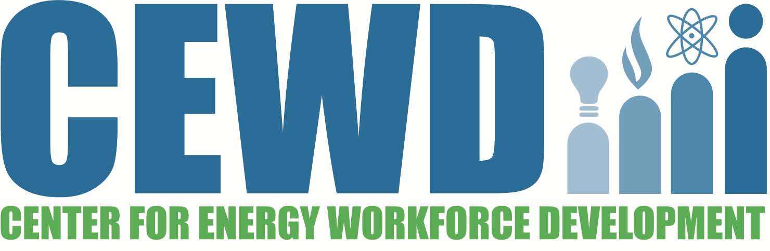

**CAREERS IN ENERGY WEEK 2022**

**Sample Proclamation**

Whereas, energy serves as the bedrock of our way of life. Energy shows up at the flip of a switch or the turn of a dial to do the work of the people of <YOUR STATE>. Energy weaves in and out of every life – invisible to most, but essential to all. An invisible matrix of power pulses throughout all modern human endeavors, felt but not seen, often overlooked but never missing; and

Whereas, energy generates commerce and fuels economic growth. Energy supports first responders and modern society’s complex systems – patient care, air traffic control, running a business or even a state. Energy supplies the many of life’s fundamental needs – heating, cooling, cooking, and lighting. Energy makes possible the fun things in life – movie watching, lighting for nighttime swims or pick-up ball games, and travel.

Whereas, energy provides careers to hundreds of thousands of residents who serve in every community. Energy careers range from lineworker to engineer, construction specialist to accountant, chemist to environmentalist, maintenance laborer to executive – all valued and all essential; and

Whereas, to promote continuity and meet the challenges of the increasing technical demands, new workers are needed to bridge into the future and maintain a skilled workforce; and

Whereas, through strategic partnerships the <NAME OF YOUR CONSORTIUM OR COMPANY> strives to promote a unified and results-oriented effort to ensure people find new and rewarding careers in energy so that <YOUR STATE> can continue to grow in prosperity;

**NOW THEREFORE, I,** (_______________, ________________) of _______________

name title town/county

do hereby proclaim the week of October 17, 2022 as

**CAREERS IN ENERGY WEEK**

in ______________ and urge all citizens to become familiar with the services and benefits offered by the career and technical education programs in this community and to support and participate in these programs to enhance their individual work skills and productivity.

**IN TESTIMONY WHEREOF,** I have hereunto set my hand and caused to be affixed the Great Seal of the (City/County) of _________________ this _______day of ______________, 2022.