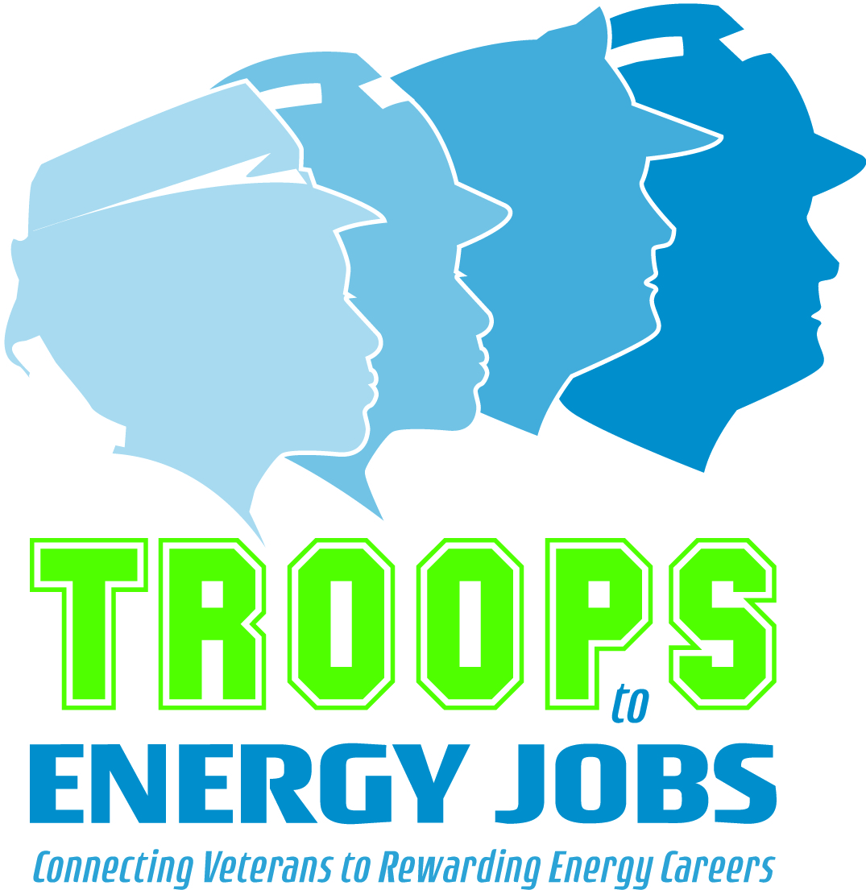
Frequently Asked Questions

What is the Troops to Energy Jobs initiative?
The Troops to Energy Jobs Initiative is an effort by investor-owned electric companies -- Dominion, American Electric Power, Southern Co., PG&E, Pinnacle West/Arizona Public Service and National Grid – to develop an accelerated process for bringing returning military veterans into the energy industry workforce nationwide.

The initiative is managed by the Center for Energy Workforce Development (CEWD) a non-profit consortium of electric, natural gas, and nuclear utilities; their associations —the Edison Electric Institute (EEI), American Gas Association (AGA), Nuclear Energy Institute (NEI), American Public Power Association (APPA)and National Rural Electric Cooperatives Association (NRECA) -- and the unions who serve these industries -- the International Brotherhood of Electrical Workers (IBEW) and the Utility Workers Union of American, AFL-CIO (UWUA). CEWD was formed in 2006 to help utilities work together to develop solutions to the coming workforce shortage in the utility industry.

Why are veterans being targeted specifically in this effort?
With nearly 40 percent of the nation’s energy workforce either eligible for retirement or departing their jobs because of attrition during the next five years, electricity and natural gas companies and the nuclear power industry are facing a potential worker shortage.

The jobs expected to be affected by this trend include engineers, technicians, line workers, plant operators, pipefitters. Many veterans, through their military assignments, training and experience are uniquely qualified for these skilled trades. But these veterans are returning without a clear path toward these jobs, and the Initiative’s goal is to define and develop this pathway.

Where can a veteran interested in a possible energy career go to find out more about career opportunities?
The best place to find out more about opportunities for veterans with energy companies is the “Military” section of the Get Into Energy website, http://military.getintoenergy.com/index.php. This web page has basic information about the different energy careers that match up best with the skills gained while in military service, energy jobs that potentially match to military jobs and available training for energy jobs across the U.S. Your local electric or natural gas utility’s job website is another potential source of information.

For Veterans who are interested in participating in the pilot company programs, information is available on the new Troops to Energy Jobs website, www.troopstoenergyjobs.com.

Where are the jobs available for veterans in the energy sector, and how many are there?
Job availability depends on the company and the region, but the Troops to Energy Jobs Initiative is being developed not only for jobs available now but also for expected job openings in the coming decade

The Center for Energy Workforce Development predicts that more than 40 percent of the workers for the nation’s electricity and natural gas companies and the nuclear power industry will be either eligible for retirement or departing their jobs because of attrition during the next 5-10 years – meaning almost 200,000 potential job openings.

Why is this initiative being undertaken now?
The purpose of this initiative is to increase the number of avenues through which veterans with applicable job skills can transition into energy jobs, or for interested veterans to begin the process of training and certification to qualify them for those jobs. . The Troops to Energy Jobs model will be designed to help enlarge the pool of potential applicants for energy industry jobs that need to be filled now and in the coming years.

The effort will focus on the needs of educators, employers and veterans, and these three groups will work together to get veterans trained, certified and ready to enter the energy workforce after they’ve departed the military. Many veterans may have some of the skills and background already needed for starting a successful energy career, but they might not realize these opportunities exist nor have the information they need to navigate the system to find the right fit. Troops to Energy Jobs also will be designed to help close those gaps.

Is anyone else involved in the Troops to Energy Jobs Initiative?
Troops to Energy Jobs and the five pilot companies will work with the U.S. Departments of Defense, Labor, Veteran Affairs, and Energy and their state and local agencies, as well as community colleges and labor unions to create a unique partnership between the U.S. military and the energy industry.

Are certain jobs in the energy sector targeted for the Initiative? What skills are needed to perform these jobs and what gaps exist for most military personnel?
This will be determined as the Troops to Energy Jobs program is built over the next two years. The positions identified and the skills required will match up with similar positions and skill sets from the military.

What branches of the military will be targeted for this program?
All branches of service will be targeted and eligible.

