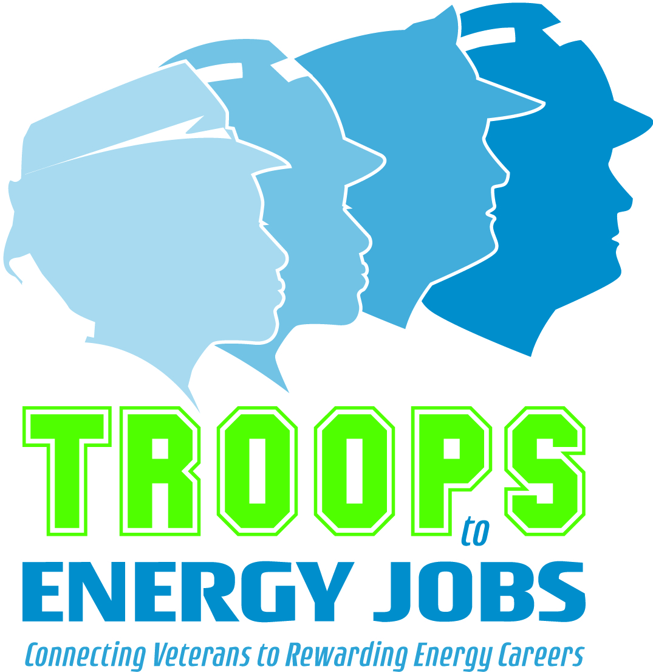
Mentoring Toolkit Overview

Below are discussion p

This Mentoring Toolkit has been designed specifically for Troops to Energy Jobs employers’ Veteran mentoring programs. However, most items included in the toolkit can be adjusted for other types of mentoring as well.

The first year on the job can be overwhelming, especially when transitioning from the military to the civilian workplace. Therefore, this toolkit provides structure for the first several months of the mentor/mentee working together to ensure that the typical issues a Veteran may have when they are new to the company can be covered.
Though there is flexibility in how often the mentor/mentee meet, it is recommended to start off with every other week, using the nine session documents included in the toolkit. After that, the mentor/mentee can decide what will work best. Below is a list of the session topics:

- Session 1: Getting to Know Each Other & Company Culture
- Session 2: Understanding One’s Job Activity
- Session 3: Understanding the Organization
- Session 4: Understanding Processes, Policies, and Procedures
- Session 5: Working with the Supervisor
- Session 6: Working with Colleagues
- Session 7: Handling Workplace Challenges
- Session 8: Handling Personal Challenges
- Session 9: Professional Development Goals

In addition, there are other helpful items included in the toolkit, including articles as well as applications and questionnaires that can be used to either jumpstart a Veteran mentoring program or enhance what your company already has in place. These include:

- Articles: What is Mentoring?; Why Mentoring Matters; Characteristics of Successful Mentors
- Guidance for Recruiting Mentors and Hosting an Orientation
- Mentor/Mentee Applications
- Mentor/Mentee Self-Assessments

If you have any questions about the Mentoring Toolkit, feel free to contact CEWD Educational Consultant, Valerie Taylor at valerie@cewd.org.

