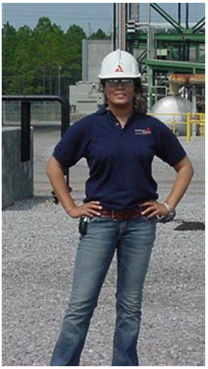
Name Angele Monconduit

High School St. Thomas Aquinas/Reitz Memorial

College University of Evansville

Degree(s) B.S. Civil Engineering

Job Title Maintenance Manager

Email amoncond@southernco.com

Hobbies Hanging out with my son, Golfing, Running, Football (GEAUX SAINTS!), Giving back to the community

Plant McDonough, Atlanta, GA.

What I do
I began my career with Southern Company as an engineer in 2002. I started working as a civil engineer lead designing structural projects for various coal and hydro plants across Mississippi, Alabama, Georgia, and Florida. Since then I have worked for Georgia Power and Alabama Power at 4 different power plants in various leadership roles in Operations and Maintenance.

Why Engineering
I always liked math and science in school so I was interested in doing something challenging and something that would make a difference. I can also remember my mother telling me, “Angele, you get that engineering degree and I promise you, you can do anything!” And she was absolutely right! I have had an awesome career so far and it’s given me the ability to take care of my family.

The best part of being an Engineer
The best part of being an engineer is the ability to use my skills to make a difference. I have been able to By having an engineering degree, it opens many doors. I’ve mostly enjoyed working in the Construction environment where you can actually see your hard efforts as the project unfolds. It is rewarding to see a stack, building, equipment, etc. be built or put into operation.

Proud Moments
I didn’t get to be an engineer on my own and without the advice and encouragement from others. It is so important to me to mentor and share my story with other young females letting them know they are just as smart and just as capable. My proud moments are reaching out to young ladies through schools visits, tours at the plants, engineering conferences, or just simple conversation. You never forget that look on their face as they realize they can do it too.

