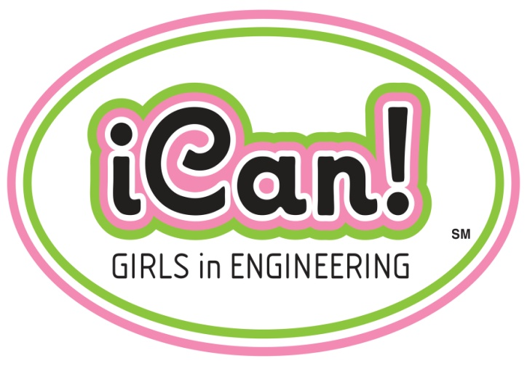

PROGRAM OVERVIEW

Created by Alabama Power, iCan creates a fun, girls-only environment for learning while sparking an interest in engineering. The program’s primary goal is to empower and encourage young women through focusing on the rewards and benefits of being an engineer. While the “full” program involves at least four school visits per year, CEWD has created a toolkit for companies to start with one visit.
Volunteers, made up of women engineers from the host company, would lead a discussion about engineering careers along with a hands-on activity. While the discussion of engineering career choices should be broad, this toolkit is based on two highly successful hands-on activities, one demonstrating chemical engineering (making lip gloss) and the other electrical engineering (creating a burglar alarm with an electrical circuit). Depending on the amount of time available, students could participate in both activities.
The direct costs to host the program are minimal. These would include materials for the hands-on activities, snacks, and copying costs for the handouts. Indirect costs are also minimal since all of the items required for the program are included in the toolkit. The main indirect cost would be the time for the women engineers to prepare for and host the event.

