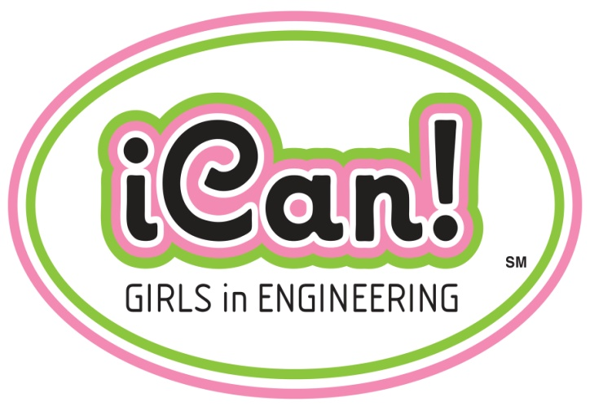 COMPANY LOGO
DATE

Dear Student,

Thank you for allowing us to share with you some information about the exciting career of engineering.

Our goal was to open your mind to the possibilities that come with pursing engineering:

It’s enjoyable – we love what we do!
Provides a good working environment
Makes a difference – you can change the world!
Pays well
Offers flexibility – allows time for family, hobbies and travel

If you think engineering could be in your future, take as much math and science as you can, use your imagination and creativity, and have fun!

Want to learn more? Check out these cool websites:

www.engineeryourlife.org
www.engineergirl.org
http://aspire.swe.org/

Sincerely,
COMPANY NAME Girl Engineers

