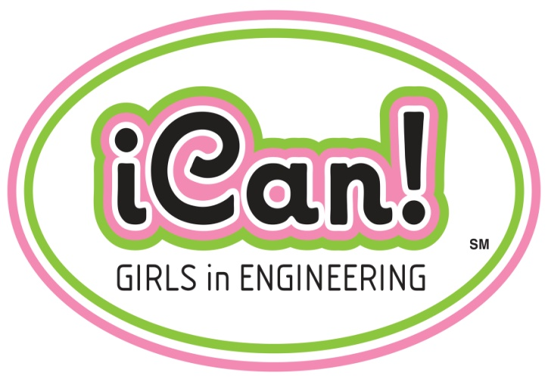 COMPANY LOGO
DATE

Dear Parent,

Today your daughter had the opportunity to learn more about the exciting career path of engineering. Not only did we have some of our women Engineers come to share about their passion for engineering, but we did some fun hands-on activities as well!

Our goal was to open your daughter’s mind to the possibilities that come with pursing engineering:

It’s enjoyable – we love what we do!
Provides a good working environment
Makes a difference – you can change the world!
Pays well
Offers flexibility – allows time for family, hobbies, and travel

Ask your daughter what she learned today. Have her check out these websites to learn more about the prospects for Engineers:

www.engineeryourlife.org
www.engineergirl.org
http://aspire.swe.org/

Sincerely,
COMPANY NAME Women Engineers

