In partnership with the Michigan Energy Workforce Development Consortium and the National Center for Energy Workforce Development, Consumers Energy is proud to participate in the 2016 Michigan Careers in Energy Week.
Careers in Energy Week
October 17-21, 2016
Schedule of Events for the week:

Monday, October 17th- Consumers Energy Marshall Training Center tour, 10:00-1:00

Tuesday, October 18th- DTE-Westland Electric Training Center tour, 10:00- 1:00
Consumers Energy, Kalamazoo Service Center tour, 3:30-5:00

Wednesday, October 19th- Consumers Energy Flint Service Center tour, 10:00-1:00

Thursday, October 20th- DTE- Melvindale Gas Training Center tour, 10:00- 1:00
Lansing Board of Water & Light Luncheon, 12:00

Friday, October 21st- Lansing Board of Water & Light tours, one morning, one afternoon

** all tours will be attended by area Jobs for Michigan’s Graduates students

Other happenings throughout the state:

MIAT- tours and open houses, held throughout the week for the general public
Michigan Veterans Affairs Agency- will be promoting careers in energy throughout the week via social media and brochure distribution
Lansing Community College, Henry Ford College, Jackson College, Alpena Community College and Michigan Workforce Development Agency - supplementary support, on site for tours

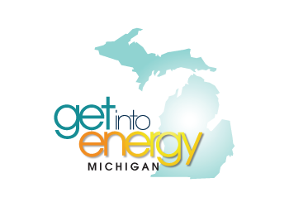
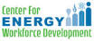
WORKING TO DELIVER THE ENERGY YOU NEED, WHENEVER YOU NEED IT.
THAT’S OUR PROMISE TO MICHIGAN.

