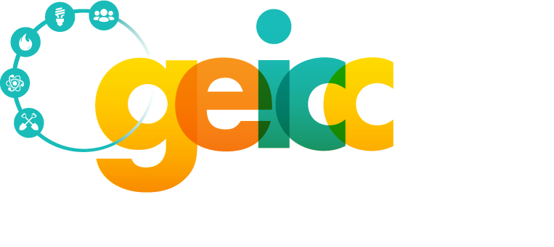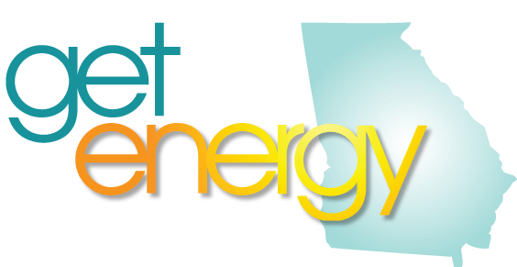

The Georgia Energy and Industrial Construction Consortium (GEICC) 2017 calendar has proven to be another successful year with our statewide footprint and participation from our members at an all-time high. Below is a recap of our accomplishments to date:

Career Awareness

Career Fairs
- March 22-25th – CEFGA Career Expo & Skills USA State competition
- 7500 student, teacher and parent attendees
- GEICC sponsored World of Energy with 80+ industry volunteers from 12 industry member corporations which included 3 new industry partners in the exhibit
- Plant and site tours
- Industry hosted approx. 20 site tours across the state at power generation and distribution facilities including nuclear, solar, gas, hydroelectric and coal fired facilities
Classroom Presentations
- During Careers in Energy week and throughout the year, GEICC members present to classrooms across the state with a focus on 3rd grade, middle schools and college & career academies
Participating in First Robotics
- March 3-April 8th – First Robotics regional and statewide competitions
- GEICC members consulted, judged and staffed the repair shop for First Robotic competitions
Supporting the GA TSA.
- March 10-11th in Athens, GA - GEICC provided competition judges and a $500 sponsorship.

Partnership with Education

Awarding Scholarships
- Awarded $100 recognition awards to students participating in the Lt. Governor’s Summit Student Panel.
- New in 2017, two $500 scholarships awarded to graduating seniors pursuing a career in the energy field from LaGrange, GA THINC Academy
GA Career, Technical & Agricultural Education Statewide Conference
- July 10th - The GEICC sponsored workshop presented by Sheree Sturgis, Director of HR – Southern Operations, Southern Company Gas, focused on careers in the natural gas industry and employability skills.
Board of Education presentation
- May 3rd - GEICC members assisted Roger Ivey, Energy Pathway CTAE liaison, present to the State Board of Education, about the suggested changes to the pathway curriculum so that it delivered content in a more logical sequence and to increase student learning that should positively impact success rates on the end of course test.
Educator Training
- June 7-9th – “Discovering Natural Gas”
- Hosted and staffed by Southern Company Gas technical training center
- 10 educators attended – expenses paid by GEICC
- Speakers included: Julie Strempko, CEWD, curriculum focus, Roger Ivey, GA BOE Energy pathway liaison, Atlanta Gas Light associates from Supply Chain Diversity, Field Training, Safety, HR, VP Operations, Fleet, Future of Gas, etc.
- Educators had networking opportunities at lunch with HR professionals and C-level execs as the GEICC Board meeting and the GEICC General Membership meetings were held concurrently.
Careers in Energy Week.
- This year the consortia focused on their local Energy Pathway schools and promoting the GEICC Energy Scholarship.
- Our individual organizations continued to promote Careers in Energy. A few of the highlights include:
  - Georgia Transmission Corporation mentoring STEM students in middle school as they work on an actual transmission line siting project. This year long project culminates with students presenting the route and defending their proposal based on research covering environmental, cost, land elevation and county zoning regulations.
  - Oglethorpe Power Corporation hosting high school STEM students at local solar installations
  - Hosting college & career academy students for tours of gas fired generation facilities
  - Local energy safety presentations
  - Southern Company Gas debuting new “My Job is…. “ social media program highlighting the multitude of careers in the natural gas industry
  - Local utility offices working career fairs with new student activity guides geared toward elementary age students and hands on labs and fun competitions to engage middle and high school students

National Careers Pathway Network
- At the request of our partner, Technical College System of Georgia, GEICC presented “The Energy Pathway, from Vision to Thriving: Georgia Industry and Education Partners Collaborate” at the NCPN Conference in St. Louis, MO on October 26th. The presentation focused a timeline of the success and growth of our pathway and the strategic partnerships that enabled the program to prosper.

Membership

General Membership Meetings.
- June 8th – Held simultaneously with teacher training at Southern Company Gas Technical training Center. Presenters included: Ken Hobart, Southern Gas Association, Tommi Paris, Manager of Diversity and Inclusion, Tremese Davis, Supply Chain Diversity and a tour of the training center
- October 11th – Presentations included:
  - Heather Teilhet, VP Governmental Affairs, OPC, discussing state and federal legislation impacting the utility industry and Georgia utilities’ decision to complete Plant Vogtle nuclear units
  - John McDonald, GE, covering IEEE Scholarship Plus and programs for STEM students
  - James Banner, VP of HR, Pike Electric, discussing hiring and retention efforts
  - Diane Sandifer and Dr. Barbara Wall, GA DOE, You Science program
  - Stephen Hopkins, Savannah Technical College, Electric Utility program
  - Bob Collins, Augusta Technical College, Nuclear program

Attending the CEWD South/Southeast Summit
- GEICC had several representatives in attendance at the May 17-18th event held in New Orleans including our TCSG partners.

Hosting GEICC Annual Golf Tournament
- May 24th - GEICC hosted its 7th annual golf tournament with 160 golfers in attendance. Funds raised support the GEICC pathway support programs, scholarships and GEICC activities like the Career Expo Skills USA conference. Lt. Governor Casey Cagle attended the tournament opening ceremony and served as our honorary chair. Net revenue was approximately $15,000.

Connecting with School Counselors
- November 4-6th - GEICC had a display booth at the Georgia School Counselors Association annual conference held in Jekyll Island. We provided an updated “Energy Pathway” poster along with a marketing brochure to the attendees. These materials continue to be a popular takeaway for the counselors.
Organization and Structure
- Pike Electric has joined the consortia as a dues paying member, bringing our total to 13 members. These members represent every utility in the state (IOU, EMCs, Municipals and Gas providers) as well as K-12 and technical education. Membership meetings continue to draw between 50 – 70 attendees.

Look Ahead for 2017-2018

GEICC has partnered with the Georgia DOE to develop the Energy Pathway playbook to serve as a guide and timeline for any school interested in starting an energy pathway. This document will provide them with all of the necessary steps to insure that they partner with their local utilities, the GA BOE, GEICC, local workforce development and chamber of commerce partners as well as local educators. Information will include cover curriculum, certification, cost to implement and classroom/ lab equipment needs, anticipated cost and design.

Plans for teacher training in June 2018 are underway and will be hosted by Georgia Transmission Corporation at their Smarr, GA training center located in middle Georgia.

Plans are also underway for the March 2018 Skills USA Career Expo.

GEICC has consulted with 3 new school systems as they consider starting their own energy pathway classes.

