Instructor Guide

First Aid
Table of Contents

Overview and Goals 3
Preparation – Facilitation Guidelines 4
Materials 5
Schedule 6
Articles for Workshop Discussions 14
Appendix 1-The Skeletal System 15
Appendix 2-The Knee 16
Appendix 3- Skin-Epidermal Layer 17
Appendix 4- Abdominal Area 18
Appendix 5- Chest Cavity 19
Appendix 6- Pressure Points to Control Bleeding 20
Appendix 7- The Skeletal System Activity Worksheet #1 21
Appendix 8–Activity Worksheet #2 22
Activity Worksheet - On the Job Scenario Actions and Treatments 22
On the Job Scenarios for Assignment (Instructor) 24
On the Job Scenarios for Assignment 26

Overview and Goals
Working with natural gas, safety is of the utmost importance, but accidents do happen. This means all personnel-on and off the job site should know the first aid guidelines and proper actions to take in any emergency, no matter what the severity. Being prepared can reduce further injuries and save lives.
In this unit of work the instructor will:
- Highlight the concepts introduced in the online course.
- Demonstrate how to use the relevant tools and reference guides, applicable to the content and activities.
- Guide the participants through hands-on activities to work safely with natural gas, as a qualified operator would on the job.

Upon completion of this unit of work, participants will be able to:
- Explain the first aid guidelines and best practices for first responders.
- Explain the importance of using the correct personal protective equipment (PPE).
- List the actions to take in an emergency that follow the OSHA standards, as well as appropriate industry guidelines such as the American Red Cross (first aid) and the American Heart Association.
Note: Specific step-by-step details and the outcomes of the demonstrations and participant activities will be determined by the materials and tools used at the training facility.

Preparation – Facilitation Guidelines
All utility workers must follow the strictest safety guidelines.

Ensure the participants have completed the following online course:
OS-0111 First Aid, including the pre-test and the 20 question course assessment

Conduct this training in a classroom setting, with a simulated lab environment using the local materials and tools for illustration, demonstration, and the hands-on workshop activities.
Note:
This class should be taught by an instructor who has First Aid, CPR, and Automated External Defibrillator (AED) training to ensure the participants are correctly introduced on how to respond to:
- Common first aid emergencies, including burns; cuts; head, neck and back injuries.
- Breathing and cardiac emergencies in adults, including the use of an AED.

During the class introduction:
- Encourage discussion through demonstrations and activities.
- Discuss the importance of participation.
- Explain that participants may work with a partner or in small groups to complete the activities. After each activity, the participants will be encouraged to present their findings for further discussion to the workshop.
Use a flipchart to capture key lessons learned from the group discussions, or to identify questions that will be answered in upcoming units of work or that require further research and discussion.
Reinforce the importance of damage prevention programs and the best practices and guidelines of the Compressed Gas Association (CGA), the Occupational Safety and Health Administration (OSHA), and the Federal Government.
Review the following regulation as tasks are introduced, demonstrated, and practiced.

- CFR 29 § 1910.151 (a) (b) (c) Medical Services and First Aid

Materials
Provide the following to each participant:
- A copy of Appendix 8–Activity Worksheet #2 for each scenario he or she is assigned.
- Upon completion of a section or sections (as appropriate for your workshop) assign scenarios for practice and or discussion. Examples might be relevant to regional events or examples can be assigned from the Appendix reference: On the Job Scenarios for Assignment.

Note: Explain that the On the Job Scenarios Activity Worksheet is comprehensive.
Although the scenarios may focus on how to handle one type of injury, for example a wound, how the victim is examined, the type of pressure applied, based on the location, the dressing used or even how to handle a bleeding victim in shock must all be considered.

- Access to the Internet, as needed, for OSHA, The American Heart Association, the American Red Cross as well as all federal, and industry resources/references that support the course related discussions, demonstrations, and hands-on activities.
- Access to manufacturer’s instructions as needed.

Provide the following materials and tools used locally for illustration, demonstration, and if appropriate hands-on practice:
- Skeletal structure or charts
- First Aid Supplies, for example:
  - Dressings
  - Bandages
  - Tourniquet
  - CPR equipment/supplies; for example resuscitation mask, gloves
  - AED
- Personal Protective Equipment, as needed

Using the local materials (skeletal structures) review the skeletal structure.
Note:
- These items, and any other materials used for demonstrations and participant activities, will be determined by the materials and tools used at the training facility
- Appendix has images similar to those in the online course work for the participants to reference if needed.
.

Schedule
Time | Topics for Discussion, Demonstrations, and Activities
30 minutes | Introduction  Explain that this module of work introduces the fundamentals of handling basic first aid and CPR training that were covered in the online course work.  Discussion  Emphasize the following points:  - Safety must be the first consideration on the job.  - All utility workers must learn the fundamentals of basic life support to ensure personal safety, as well as that of the people with whom he or she is working and the victims of an incident.  - The eight OSHA standards for First Aid requirements which require that companies supply first aid supplies/tools and train personnel to administer first aid and CPR.  - The importance of first aid and CPR training for everyone.  - Basic first aid training gives one the knowledge, experience and confidence to identify and help in emergency cases to care and monitor a person in distress until medical care arrives.  Explain that there are several factors to consider when handling all incidents. This starts by learning how to:  - Assess the situation: determine, if possible what caused the injury  - Victim  - Injuries  - Request medical assistance as needed  - Deal with bloodborne pathogens  In addition, explain the influence of health and safety guidelines such as those provided by the American Red Cross, the American Heart Association, OSHA, and “Good Samaritan Laws.”  Note: If Good Samaritan Laws apply in the region, review the details.
45 minutes | Topic: Importance of Training skills and Best Practices  Explain that this course focuses on apply good practices with proper response, evaluation strategies (using the appropriate industry terms/jargon) with basic first aid training, for a wide range of topics:  - The human anatomy  - Response techniques  - CPR  - First aid supplies  - Bleeding  - Shock  - Burns  - Electrical shock  - Head and spinal injuries  - Fractures  - Poisoning  - Environmental Emergencies  Topic: Importance of Training skills and Best Practices , Continued  Discussion  Encourage real-world experiences that illustrate, no matter how detailed our efforts are to avoid accidents or problems, we are inevitably faced with emergencies on and off the job.  Point out, that even though we may have time to study and prepare for the “how-to” situation, we have no prep time when an emergency happens, we just have to react/respond, which is why everyone has to be prepared with the skills and tools to handle the job.
30 minutes | Topic: Basic First Aid  Discussion  - Explain that once the situation is safe, it is important to know how to examine and respond to a victim.  - Point out that it is important to know the skeletal parts to ensure you visually check a victim who is ill or injured from head to toe to avoid overlooking  - Any problems.  - Medical identification tags  Demonstration-Basic Anatomy  Hand out Appendix 1-The Skeletal System.  Using the local materials (skeletal structures or pictures) review the skeletal structure  Optional Activity: Instruct participants to complete Appendix 7- The Skeletal System Activity Worksheet #1.
30 minutes | Topic: Response, Evaluation, and Examination  Discussion  - Explain the precautions to take during an initial response including:  - The appropriate personal protection equipment (PPE)  - How to approach the victim  - Follow the “S.A.M.P.L.E” model  - Signs and symptoms  - Allergies  - Medications  - Past history of these symptoms  - Last oral intake  - Events leading up to accident or injury
60-90 minutes | Topic: Cardiopulmonary Resuscitation  Demonstration  - If the PPE and CPR tools are available demonstrate, and then have the participants administer hands-only Cardiopulmonary Resuscitation (CPR)  - Emphasize hands-only CPR includes:  - Compressions  - Airway  - Breathing  Topic: Cardiopulmonary Resuscitation, Continued  - If the PPE and CPR tools are available demonstrate how to administer Cardiopulmonary Resuscitation (CPR) with an AED.
30  minutes | Topic-“Head to Toe”  Demonstration  How to conduct a head to toe secondary examination once you are ensured the victim is breathing and has a pulse.  Ask for a participant to volunteer and show how a first responder would examine a victim’s:  - Head  - Face  - Neck  - Chest  - Abdomen  - Arms Legs  - Back
45 minutes | Topic: Bleeding and Wounds  Discussion  - Reinforce the online course material, which explains that  - The average adult body has between 6 and 7 liters of blood that circulates through one’s body under pressure by the cardiovascular system .  - Severe bleeding can cause inadequate blood volume and pressure causing the human body to collapse.  - Point out how, on the job, you will need training  - To handle bleeding that is caused by cutting, perforating or tearing skin.  - To know if the bleeding was a result of damage to one’s arteries, veins, or capillaries  Demonstration - Methods to Control Bleeding  - Hand out Appendix 6- Pressure Points to Control Bleeding  - Explain why the technique is use, and how to:  - Find a pressure point which is important to control blood loss due to arterial bleeding  - Apply direct pressure  - Elevating a bleeding part with direct pressure if there are no fractures  - Apply a tourniquet (which is a last option) to stop bleeding.  - Tie a square knot  - Apply a non-adherent pad or dressing  Explain the characteristics of the different types of wounds:  - Incision  - Laceration  - Abrasion  - Puncture  - Avulsion  - Amputation  - Nosebleed  Topic: Bleeding and Wounds, Continued  Review the symptoms of internal bleeding:  - Tender, swollen, bruised area of the body  - Rapid or weak pulse  - Skin that is cool or bluish in color  - Coughing up blood  - Confused, drowsy, or unconscious  Explain how to treat a wound if necessary before the victim receives medical attention.
30 minutes | Topic: Shock  Discussion  - Explain:  - When any part of the circulation system fails to provide enough blood, shock occurs.  - That the nervous system and its sensory and motor nerves impact the cardiovascular system and when there is not enough circulation a victim can go into shock.  - This means:  - Blood is lost  - Vessels dilate and there is insufficient blood to fill them  - The heart fails to act properly as a pump to circulate the blood  - The signs and symptoms of shock include:  - Pale skin  - Dilated eyes  - Rapid breathing  Demonstration  - How to treat shock  - Have victim lie down and rest in a comfortable position  - Control any external bleeding  - Maintain normal body temperature - cover with a blankets  - Elevate legs 8-12 inches (if there is no sign of chest, head, neck, or spinal injury)  - Call local emergency number  - Point out that the victim must rest in a comfortable position and be covered with blankets.
20 minutes | Topic: Burns and Scalds  Discussion-Burns  Explain  - Burns, which can cause disfigurement, scarring, and severe pain can be classified by:  - Cause:  - Chemical,  - Thermal,  - Electrical  - radiation  - Degree:  - First degree are considered superficial, damage the top layer of skin and generally heal in five to six days  - Second degree burns are moderate, may scar and require several weeks to heal  - Third degree are deep burn which destroy tissues and can damage tissues and bone  - Burns are a result of  - Flame  - Hot objects  - Chemicals  - Electricity  - Radiated heat  - Frozen surfaces  Scalds are caused by contact with boiling fluids or steam.  Only very minor burns should be treated with creams or ice. All other burns should be treated with cool water and non-adherent dressings. Call 911.
15  minutes | Topic: Electric Shock  Discussion  Explain  - A human body can be a conductor of electricity and may cause burns or even stop one’s heart.  - The person must be disconnected from the electrical source with extreme care to ensure that neither the rescuer, nor the victim, receives any further shocks.  - Remove the electrical source using non-conducting materials, for example, boards, non-conducting ropes, blankets.  - The symptoms include: difficult breathing, weak or irregular pulse, burns, entrance and exit wound burns, collapse  - Follow the guidelines to treat electric shock: according to your first aid training:  - Cool and cover the burns with non-adherent dressings.  - Seek medical assistance.
20 minutes | Topic: Head Injury  Discussion  - Explain  - Head and spinal injuries are very serious and if not treated properly can cause lifetime injuries and/or death.  - Head and spinal injury victims must always seek medical attention. No exceptions.  - It is important to identify the cause of the head injury.  - Encourage a discussion on what might cause a head injury, with an emphasis on unsuspecting types of accidents. This will ensure that the participants conduct due diligence to look carefully for signs of head injuries, which includes:  - Blurred and double vision  Topic: Head Injury, Continued  - Leaking fluid from nose or ears  - Obvious head wounds and  - Altered levels of consciousness.  - Headache  - Nausea and/or vomiting  - Confusion  - Facial bruising (around eyes and ears) is a delayed sign  - Reinforce  - Movement of the victim must be minimal.  - Minimize the victim's movement and treat any wounds.  - Do not allow the victim to return to work or to an activity.
20  minutes | Topic: Spinal Injury  - Explain  - Signs of spinal column injuries include:  - Generally slow pulse  - Unnatural position  - Body bent in awkward position  - Tingling, unusual, or absent feeling in extremities.  Ask participants to give examples of what might cause a spinal injury.  Explain that Spinal shock is an injury where the spinal column is subject to a forceful blow, but no lesion occurs. However the first aid responder should in his or her initial examination treat spinal shock as though it was a spinal injury.  - Reinforce  - Movement of the victim must be minimal.  - Minimize the victim's movement and treat any wounds.  - Treat for shock and for any other immediate injuries. I
30  minutes | Topic: Fractures  Discussion  - Explain  - A fracture is a complete break, crack, or chip in a bone.  - Fractures are classified as:  - Open: an injury where the bone has fractured and penetrated the skin leaving a wound  - Closed: an injury where the bone has fractured but has no obvious external wound  - Signs include;  - Hearing a pop or snap at the time of injury  - Pain at the site of injury  - Deformity of the limb  - Loss of use of the limb  - Bruising or swelling  Topic: Fractures, Continued  Point out the importance of immobilizing the injury site to prevent further injury, apply ice to prevent swelling, and seek medical attention.  Encourage a discussion on what might cause a fracture.  Demonstrate, using the local materials in the training room how to immobilize fractures using:  - A soft splint  - A sling  - A rigid splint  Reinforce in the demonstration the importance of checking the victim’s pulse and circulation before and after applying the splint.  - Instruct the participants to work as teams and practice setting a fracture.  - Evaluate how the fractures are set.
20  minutes | Topic: Poisoning  Discussion  Explain  - Poisons are defined as any substance that causes injury illness or death as it enters the body.  - Poisons can enter the body through ingestion, absorption, inhalation, or injection.  - Explain signs that indicate poisoning:  - Unusual odors  - Open medicine cabinets  - When positioning is suspected,  Try to identify what was swallowed, how much, and when  Call poison control: 1-800-222-1222
30  minutes | Topic: Environmental Emergencies  Discussion  - Explain that many utility workers have jobs where they are outside all the time, and can be affected by weather/nature causing on the job injuries, for example:  - Heat stress  - Extreme cold: Hypothermia  - Insect bites  - Anaphylactic shock  - Snakebites  - Emphasize that not all injuries are due to an accident. .  - Review the following with the participants.  - Heat and cold stress are brought on by the body's inability to deal with excess heat or extreme cold.  Topic: Environmental Emergencies, Continued  - Types of heat stress:  - Heat cramps  - Heat exhaustion  - Heat stroke  - Treatment consists of cooling the victim by loosening tight clothing, applying cool, wet cloths and providing cool water to drink.  - Types of extreme cold:  - Hypothermia  - Frost bite  - Treatment consists of warming the victim when they are cold.  - Insect bites are painful, but not usually fatal. Bee stings are the most common.  - To treat an insect sting:  - Scrape the stinger from the skin with a fingernail or credit card.  - Grab the stinger to remove it but avoid its venom sac.  - Wash the sting with soap and water.  - Cover it to keep it clean and apply a cold pack to reduce pain and swelling.  - Watch for signs of an allergic reaction.  - Anaphylactic shock is a life-threatening emergency. The best treatment is a shot of epinephrine.  - Snakebites  - Victim must be taken to the hospital immediately  - Do not apply cold  - Do not use a tourniquet  - Do not make incisions in the fang marks  - If possible keep the injured part of the boy lower than the heart  - The most effective treatment for snakebite is an anti-venom shot.
90 min | Instruct participants to complete Appendix 8–Activity Worksheet #2

Articles for Workshop Discussions
Note: This table will be updated by instructor to reflect articles which address current events. Refer to current and timely articles to further illustrate a point. Examples are listed in the following chart.
Article Name/Author | Date | Link
Department of Labor Issues Report on Report of Fatal Occupational Injuries in Maine by WorkersCompensation.com |  | http://www.workerscompensation.com/compnewsnetwork/news/17093-department-of-labor-issues-report-on-report-of-fatal-occupational-injuries-in-maine.html
Emergency Rooms Seeing Increased Number of Snake Bite Cases | July 3, 2013 | http://arkansasmatters.com/fulltext?nxd_id=676352
Five Texas Utility Workers Suffer Serious Burns KWTX.com | June 20, 2013 | http://www.kwtx.com/home/headlines/Five-Texas-Utility-Workers-Suffer-Serious-Burns-212340291.html
Health care employees suffer more on-the-job injuries and illnesses than other workers  By Sherry Jaobson sjacobson@dallasnews.com | July 16 | http://thescoopblog.dallasnews.com/2013/07/health-care-employees-suffer-more-on-the-job-injuries-and-illnesses-than-other-workers.html/
City Council intern passes out at press conference — and it takes EMS 30 minutes to respond By Juan Gonzalez , Jennifer Fermino AND Joe Kemp / NEW YORK DAILY NEWS | July 16 | http://www.nydailynews.com/new-york/ambulance-takes-30-minutes-respond-press-conf-article-1.1400008
Summer safety: Signs and symptoms of heat exhaustion, heat stroke | July 16 | http://www.newsnet5.com/dpp/news/health/summer-safety-signs-and-symptoms-of-heat-exhaustion-heat-stroke
Add articles to the list as appropriate

Appendix 1-The Skeletal System
Front View (Anterior) | Back View (Posterior)
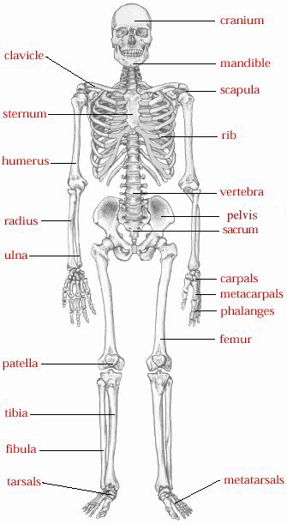 | 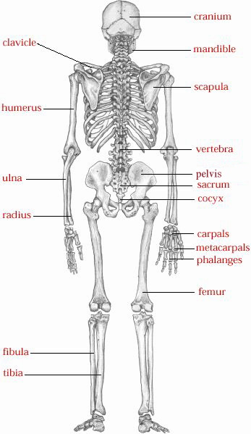
In works citation:
Skeletal system. Retrieved from
http://hes.ucfsd.org/gclaypo/skelweb/skel04.html

Appendix 2-The Knee

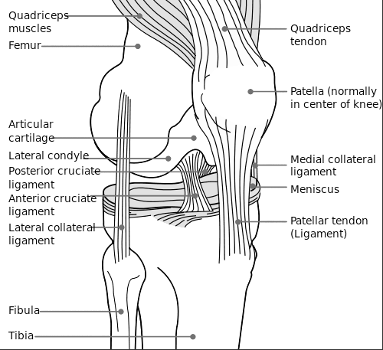

In works citation:
Knee Diagram Retrieved from
http://upload.wikimedia.org/wikipedia/commons/thumb/0/09/Knee_diagram.svg/500px-Knee_diagram.svg.png

Appendix 3- Skin-Epidermal Layer

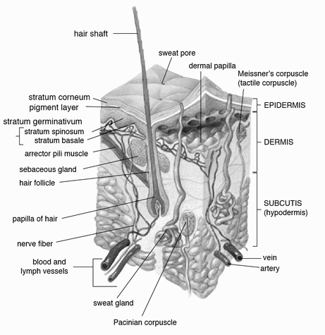

In works citation:
Knee Diagram Retrieved from
http://upload.wikimedia.org/wikipedia/commons/thumb/2/27/Skin.png/466px-Skin.png

Appendix 4- Abdominal Area

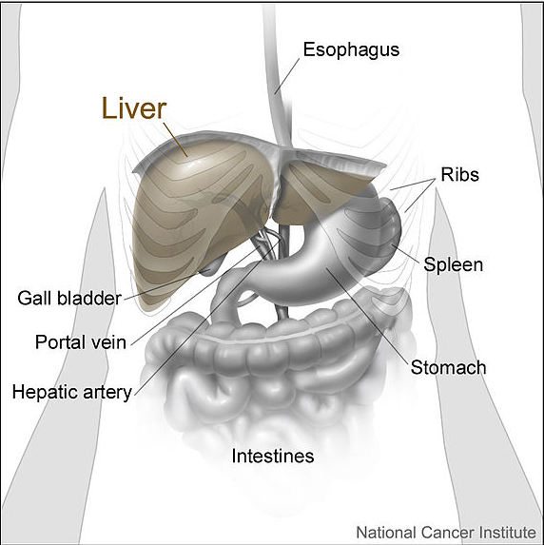

In works citation:
Diagram Retrieved from
http://commons.wikimedia.org/wiki/File:Liver_and_nearby_organs.jpg
This work has been released into the public domain by its author, Don Bliss (Illustrator)

Appendix 5- Chest Cavity

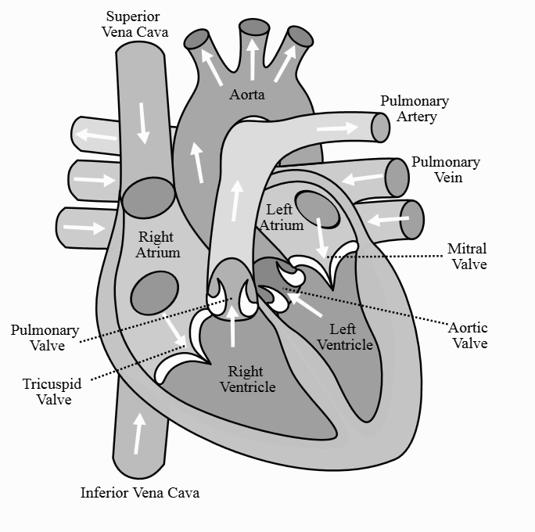
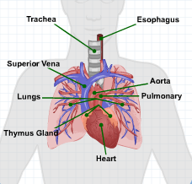

In works citation:
Diagram Retrieved from Energy U-OS-0111 First Aid, Module 2-First Aid

http://commons.wikimedia.org/wiki/File:Diagram_of_the_human_heart_%28cropped%29.svg
This file is licensed under the Creative Commons Attribution-Share Alike 3.0 Unported license.

Appendix 6- Pressure Points to Control Bleeding

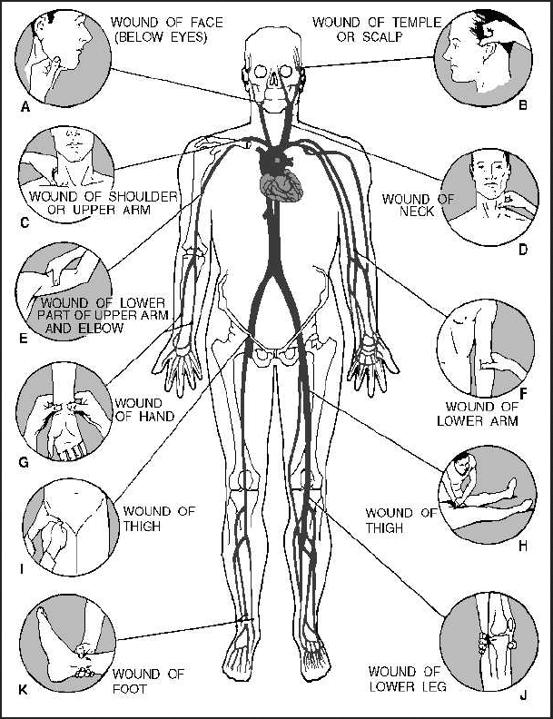
In works citation:
Diagram Retrieved from
http://commons.wikimedia.org/wiki/File:Pressure_points.jpg
This file is a work of a sailor or employee of the U.S. Navy, taken or made as part of that person's official duties. As a work of the U.S. federal government, the image is in the public domain.

Appendix 7- The Skeletal System Activity Worksheet #1
Fill in the names of the numbered skeletal parts.

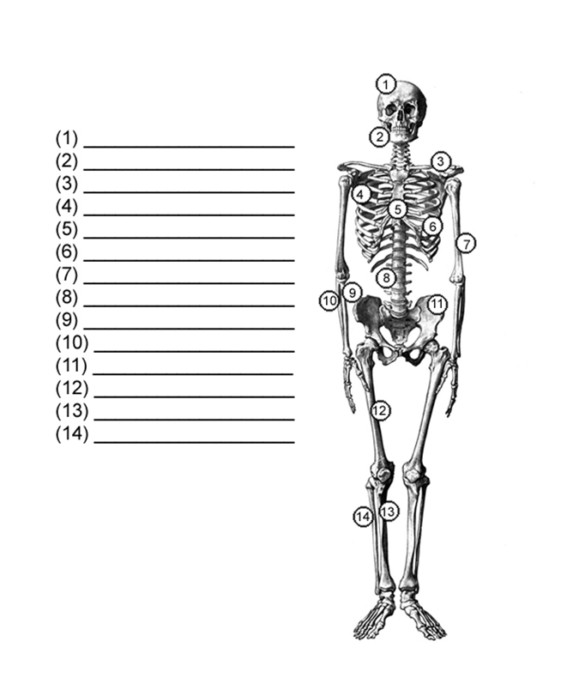

Appendix 8–Activity Worksheet #2

Activity Worksheet - On the Job Scenario Actions and Treatments
Scenario  ____________________  Indicate the scenario assigned. | - Explain what measures to take to secure the safety of the victim and surrounding as needed.  - Identify what steps were followed to:  - Assess the victim’s injury  - Apply appropriate first aid measures  - Supplies used  - Conduct follow-up support  - Indicate potential problems if qualified medical treatment is not followed.  - Identify the follow up actions taken in relation to documentation.  - List the safety guidelines (OSHA, American Red Cross CPR training, Good Samaritan laws) to which you adhered.
Notes on how the evaluation was made
Injury or emergency condition.
Explain how the determination was made.

First aid measures taken including supplies use. Explain why.
Explain what type of support was requested/and or suggested.

Page 1 of 2

Activity Worksheet-On the Job Scenario Actions and Treatments, Continued
Indicate potential problems if qualified medical treatment is not followed.

What follow-up actions did you take? Why?
List the safety guidelines (OSHA, American Red Cross CPR training, Good Samaritan laws, and so on, to which you adhered

Lessons learned

General discussion questions or notes
Page 2 of 2

On the Job Scenarios for Assignment (Instructor)
Instructor Notes:

Use regional examples or examples from this list that can be assigned with the materials and tools available at the training facility.

Participants will be asked to evaluate the situation completing the Activity Worksheet for On the Job Scenario Actions and Treatments .

Scenario #1 | On the job, Tom trips and falls on a sharp metal object.  - His arm is cut and bleeding.  - What should you do?  - Why?
Scenario #2 | A small gas tank exploded and the installer was thrown to the ground by the blast.  Part 1  - His partner on the scene sees his partner but the area is not safe.  - What should he do?  Part II  When the installer reaches his partner he finds him disoriented, his eyes are dilated and he is experiencing rapid breathing.  - What should he do?  - Why?
Scenario #3 | A utility worker falls and cuts his right forearm.  - How do you assess and treat this injury?  - Why?
Scenario #4 | A hot water pipe explodes and two installers are scalded.  How is this injury treated?
Scenario #5 | A worker trips over a large pipe and takes a bad fall. He cannot walk.  How do you assess and treat this injury?  Why?
Scenario #6 | An installer experiences a severe cut on his forearm and the bleeding is heavy.  How can you control the blood loss?
Scenario #7 | After fainting on the job, the first aid responder indicates that it is important to conduct a “head-to-toe” examination.  - When is this determination made?  - What do you examine? What conditions are you looking for?
Scenario #8 | During an excavation in the summer a worker becomes disoriented and faints.  Further examination reveals that the worker is disoriented and has the following symptoms:  - Temperature of 105 degrees F  - Dizziness and light-headedness  - Lack of sweating despite the heat  - Red, hot, and dry skin  - Nausea and vomiting  - Rapid, shallow breathing  What does this evaluation reveal?  What should the first aid responder do to treat the worker? Why?
Scenario #9 | Equipment blew a fuse while the installer was setting up the work area, and caused a wire to fall on him and burn his chest.  - As a first responder, what do you do?  - What materials will you use?  - How do you assess the victim?  - What tools do you use?  - What actions do you take?  Why?

On the Job Scenarios for Assignment
- Review the assigned scenario
- Answer the questions on the Activity Worksheet for On the Job Scenario Actions and Treatments, .

Scenario #1 | On the job, Tom trips and falls on a sharp metal object.  - His arm is cut and bleeding.  - What should you do?  - Why?
Scenario #2 | A small gas tank exploded and the installer was thrown to the ground by the blast.  Part 1  - His partner on the scene sees his partner but the area is not safe.  - What should he do?  Part II  When the installer reaches his partner he finds him disoriented, his eyes are dilated and he is experiencing rapid breathing.  - What should he do?  - Why?
Scenario #3 | A utility worker falls and cuts his right forearm.  - How do you assess and treat this injury?  - Why?
Scenario #4 | A hot water pipe explodes and two installers are scalded.  How is this injury treated?
Scenario #5 | A worker trips over a large pipe and takes a bad fall. He cannot walk.  How do you assess and treat this injury?  Why?
Scenario #6 | An installer experiences a severe cut on his forearm and the bleeding is heavy.  How can you control the blood loss?
Scenario #7 | After fainting on the job, the first aid responder indicates that it is important to conduct a “head-to-toe” examination.  - When is this determination made?  - What do you examine? What conditions are you looking for?
Scenario #8 | During an excavation in the summer a worker becomes disoriented and faints.  Further examination reveals that the worker is disoriented and has the following symptoms:  - Temperature of 105 degrees F  - Dizziness and light-headedness  - Lack of sweating despite the heat  - Red, hot, and dry skin  - Nausea and vomiting  - Rapid, shallow breathing  What does this evaluation reveal?  What should the first aid responder do to treat the worker? Why?
Scenario #9 | Equipment blew a fuse while the installer was setting up the work area, and caused a wire to fall on him and burn his chest.  - As a first responder, what do you do?  - What materials will you use?  - How do you assess the victim?  - What tools do you use?  - What actions do you take?  Why?

